**IHCI Week-2 Tutorial Activity**

**Rules :**

– Submit a Google Doc, NOT a PDF or a Google slide.

– Use the default fonts, line spacing, and font size unless specifically required in the assignment.

– After submission, the Google Doc will get automatically locked, so you won't be able to make any changes.

– Standard plagiarism rules apply

– Your submission will not be considered for grading and feedback if you do not follow these guidelines.

**Name :KRISHNA SHUKLA**

**Roll No. :2022254**

**HCI Group No. :13**

**Activity :**

Take the application Amazon (Either on a Smartphone or the Web Version)

* What was the target User Base for Amazon?
* Is Amazon an example of Good Design or Bad Design? Why?
* Is there anything the developers and designers can do to improve Amazon and better cater to the users? If not, how did the designers ensure that it would cater to the User Base? (For improvements, you can either list them out or sketch them on a piece of paper and upload it)

**Start your activity here :**



Q 1) What was the target User Base for Amazon?

A 1)The user using amazon are mainly from the age of 15 to 60. Still, it targets all users below 15 and above 60 who are immature and technology-backward, respectively, as they request people from ages 15 to 60 to buy items. It could target all users as it caters to everything individuals require. Nowadays, it is also catering to OTT and Music

Q 2) Is Amazon an example of Good Design or Bad Design? Why?

A 2) Amazon is a good design as

1)*Diversified products:* Amazon has almost all the products you name it and provides you.

2)*Customer satisfaction:* For Amazon, it is the customer who comes first, and it takes feedback from customers and customer problems seriously.

3)*Innovation:* the app is constantly innovating from Alexa to echo to prime subscription and its benefits, including amazon music, excellent video, and prime delivery. It always has a revolutionary idea.

Q 3) Is there anything the developers and designers can do to improve Amazon and better cater to the users? If not, how did the designers ensure that it would cater to the User Base? (For improvements, you can either list them out or sketch them on a piece of paper and upload it)

A 3) Amazon has a little difficulty in applying the filters as it buffers after every click, but the developers are successful in catering to its extensive user base:

1)*Usability:* the app provides almost all the products and services required at your doorstep.

2)*Simplicity:* the app or webpage is straightforward to use.

3)*Accessibility:* the app usually provides the item at a cheaper cost when compared to its rivals or local shops.

4)*Customer-centric/feedback:* the app takes customer feedback and suggestions very seriously and constantly keeps on improving.

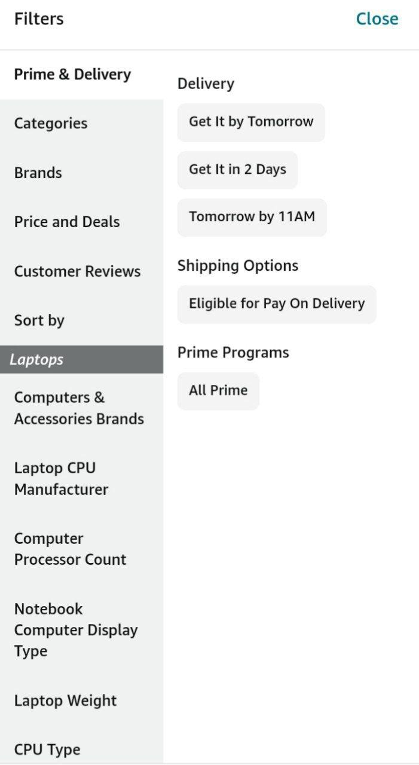

Image sources - Mobile Screenshots